The role of $a0 is to store the addresses of the array (1, 10, 20) values respectively. From $a0 you can dereference each value individually. This is done with the code:

lw $t5, ($a0) – Loads 1 into register $t5 (destination) from ($a0) (source)

lw $t4, 4($a0) – Loads 10 into register $t4 (destination) from 4($a0) (source)

lw $t3, 8($a0) – Loads 20 into register $t3 (destination) from 8($a0) (source)

The LW instructio­­n loads data from the data memory through a specified address, with a possible offset, to the destination register.

It's syntax is: LW **$destination register's address, offset**($source register's address).

Screenshot 1:

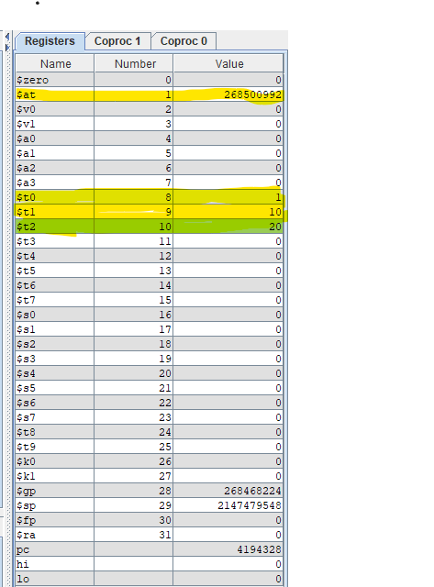

Screenshot 2:

